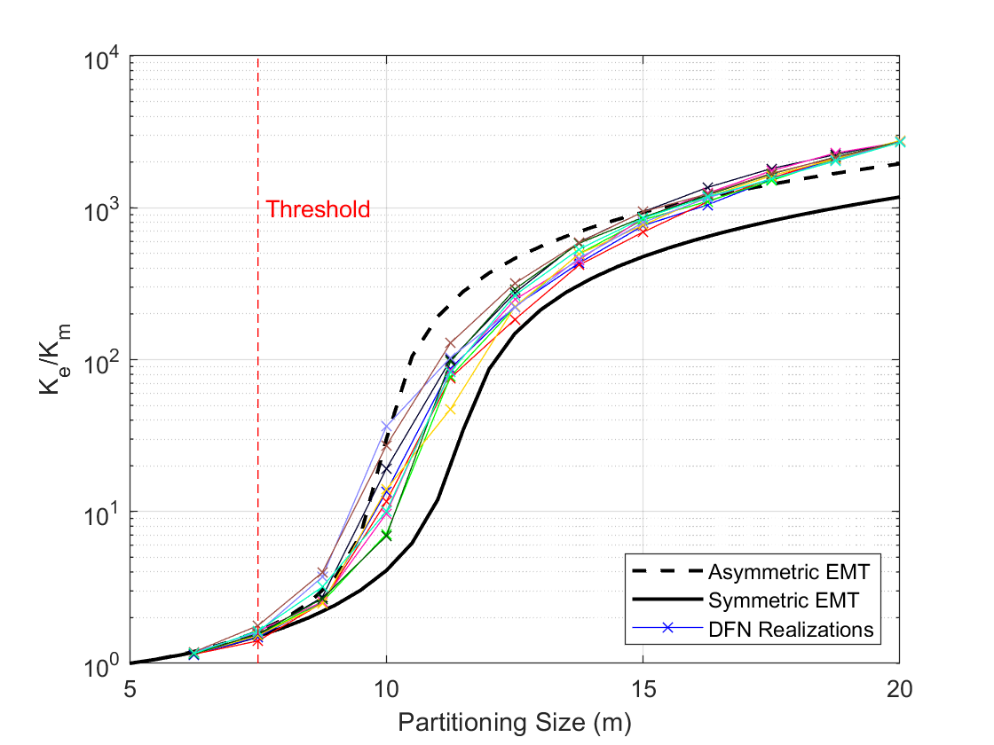

Figure 1: Fracture Subset Upscaling for 3D DFNs containing fractures ranging from 10m to 40m in diameter but having a constant aperture of 1.225mm. The effective permeavility-partitioning size relationship shows a rapid increase starting from a threshold of 7.5m. This is similar to all the other cases presented in the manuscript.

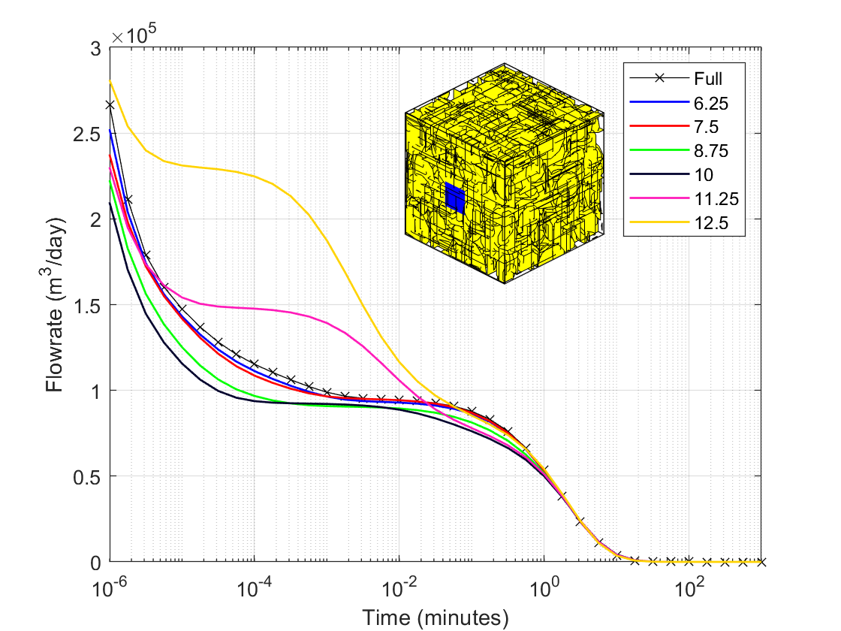

Figure 2: Drawdown curves for fully resolved and hybrid models. Apertures are fixed for all fractures. The matrix permeabilities in the hybrid models are enhanced beyond the original matrix permeability due to the integration of small fractures into the background permeability. Beyond a partitioning size of 7.5m, hybrid model results begin to deviate from the fully resolved model solution. This is again consistent with the findings shown in the manuscript for all the other cases.